
Student Name: Faith Wanja Gichure
Admission Number: BSCCS/2024/31978
Course: Bachelor in Science in Computer Science
Unit Code: BIT3208
Unit Name: Advanced Web Design and Development
Lecturer Name: Mr Nyoro Michael
Project Title: WildKenya - Virtual Safari Guide & Kenya Parks Portal
Technologies: PHP + MySQL
GitHub Link: https://github.com/faith-dev122/wildkenya-portal

Table of Contents
WEEK 1- Installation Process 4
Fig 1-Proof of installation of XAMPP 4
Fig 2-XAMPP Control Panel, Apache and MySQL green 5
Fig 3-Browser at http://localhost 5
Fig 4-Browser at http://localhost/wildkenya/hello-world.php 6
Fig 5-phpMyAdmin showing wildkenya database and 7 tables 6
WEEK 1 REFLECTION 6
WEEK 2 - Wireframes and GUI Design 7
Fig 2-Draw.io wireframe, Dashboard 9
Fig 3-Screenshot of Homepage 10
Fig 4-WildKenya navigation bar showing colour theme and main menu structure 10
Fig 5: Login and register page wireframes showing form layouts side by side 10
WEEK 2 REFLECTION 10
WEEK 3 - JavaScript and PHP Basics 11
Fig 1-Register form showing a validation error 12
Fig 2-Register form showing the password strength bar changing 12
Fig 3- PHP variables demo showing echo output, PHP version and server information 13
Fig 4-PHP mysqli_connect() database connection test returning Connected Successfully 14
Fig 5: DOM manipulation live text preview updating review content in real time 14
WEEK 3 REFLECTION 15
WEEK 4 - Server-Side PHP and Authentication 16
Fig 1-Login page 16
Fig 2- Incorrect password error 17
Fig 3-Dashboard after successful login 17
Fig 4-project folder structure 18
Fig 5-phpMyAdmin users table showing hashed password 18
WEEK 4 REFLECTION 18
WEEK 5 - Database CRUD Operation 19
Fig 1-Admin parks table 19
Fig 2-Add New Park form filled in 19
Fig 3-New Park appearing in the parks list after saving 21
Fig 4-phpMyAdmin showing a SELECT query result 22
Fig 5-Admin Animals page showing all 15 species 22
WEEK 5 REFLECTION 22
WEEK 6 - CAT 1 Complete Application 23
Fig 1-Full Wild Kenya homepage 24
Fig 2-Wildlife page with conservation filter active 24
Fig 3-Park detail page showing wildlife list and reviews 26
Fig 4-Booking page with live cost calculator showing a total 26
Fig 5-GitHub repository at github 27
WEEK 6 REFLECTION 27

WEEK 1- Installation Process
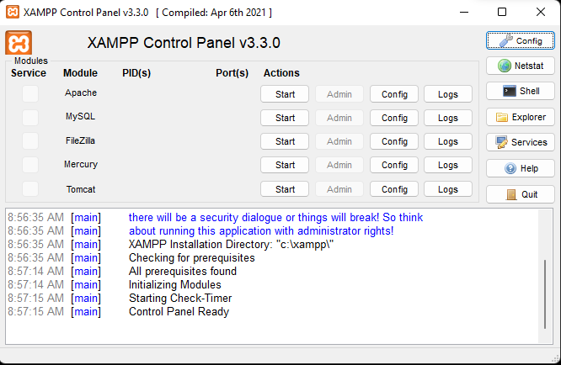

Fig 1-Proof of installation of XAMPP

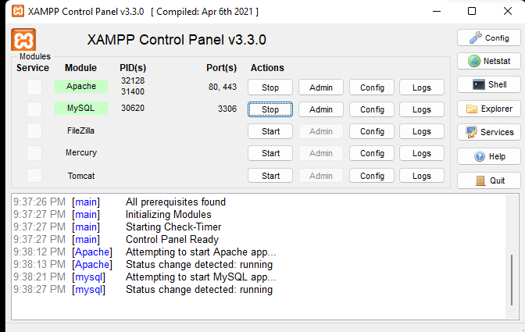

Fig 2-XAMPP Control Panel, Apache and MySQL green
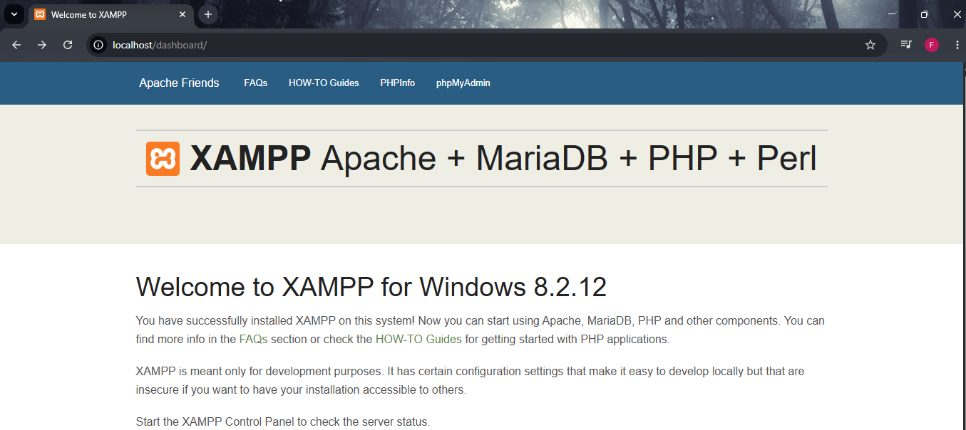
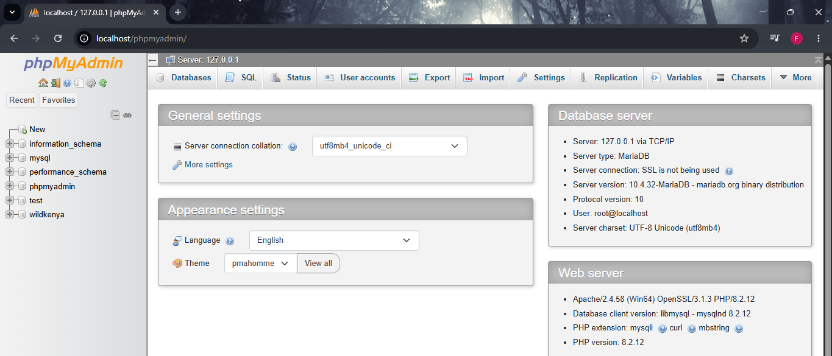

Fig 3-Browser at http://localhost

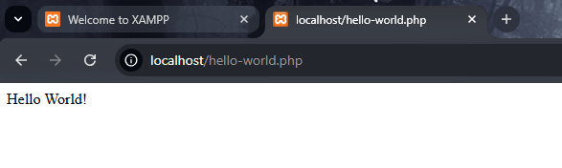

Fig 4-Browser at http://localhost/hello-world.php
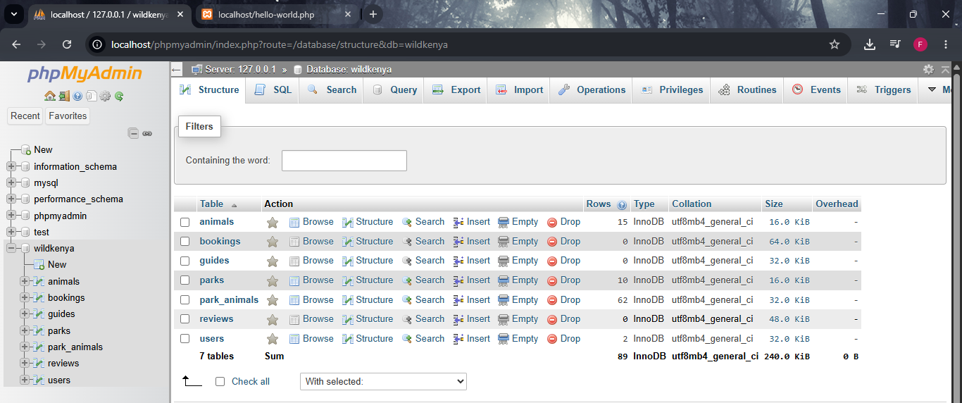

Fig 5-phpMyAdmin showing wildkenya database and 7 tables

WEEK 1 REFLECTION

Installed XAMPP (Apache web server and MySQL database for local web development) on Windows 11 this week. The PHP pages are served by apache on localhost:80 and application data is stored in mysql. In Fig 2 both services are up and running in the XAMPP Control Panel. Browser is running at local host as seen in the figure 3. In Fig 4, you will find a working PHP page that shows hello world. In the phpMyAdmin, after import wildkenya.sql file and creating all 7 tables, a successful connection with the wildkenya database is achieved as shown in Fig 5.

WEEK 2 - Wireframes and GUI Design

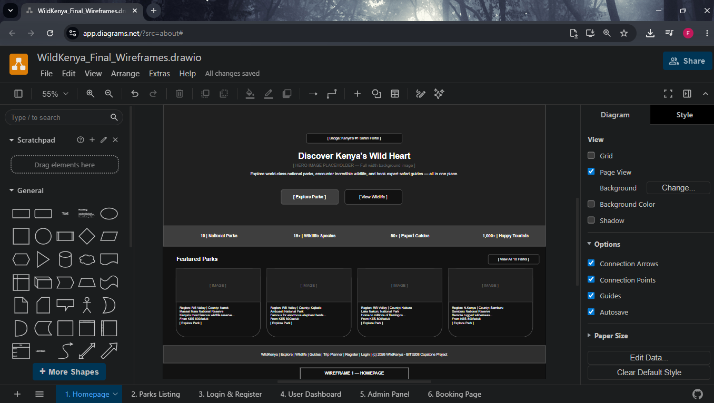
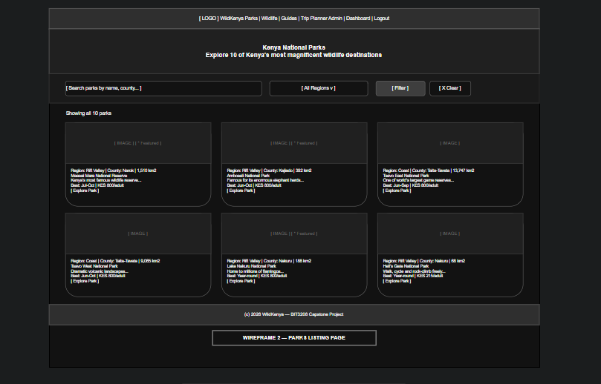Fig 1-Draw.io wireframe, Homepage
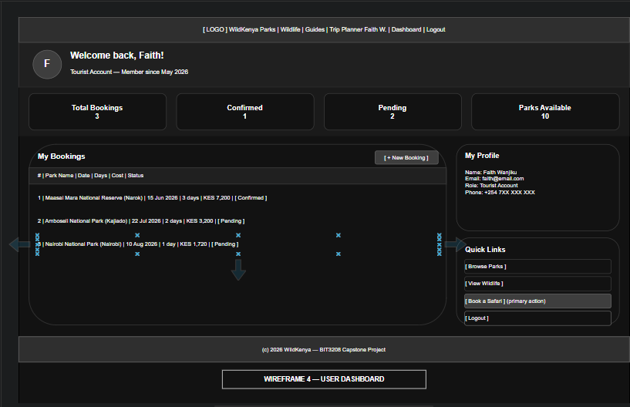

Fig 2-Draw.io wireframe, Dashboard
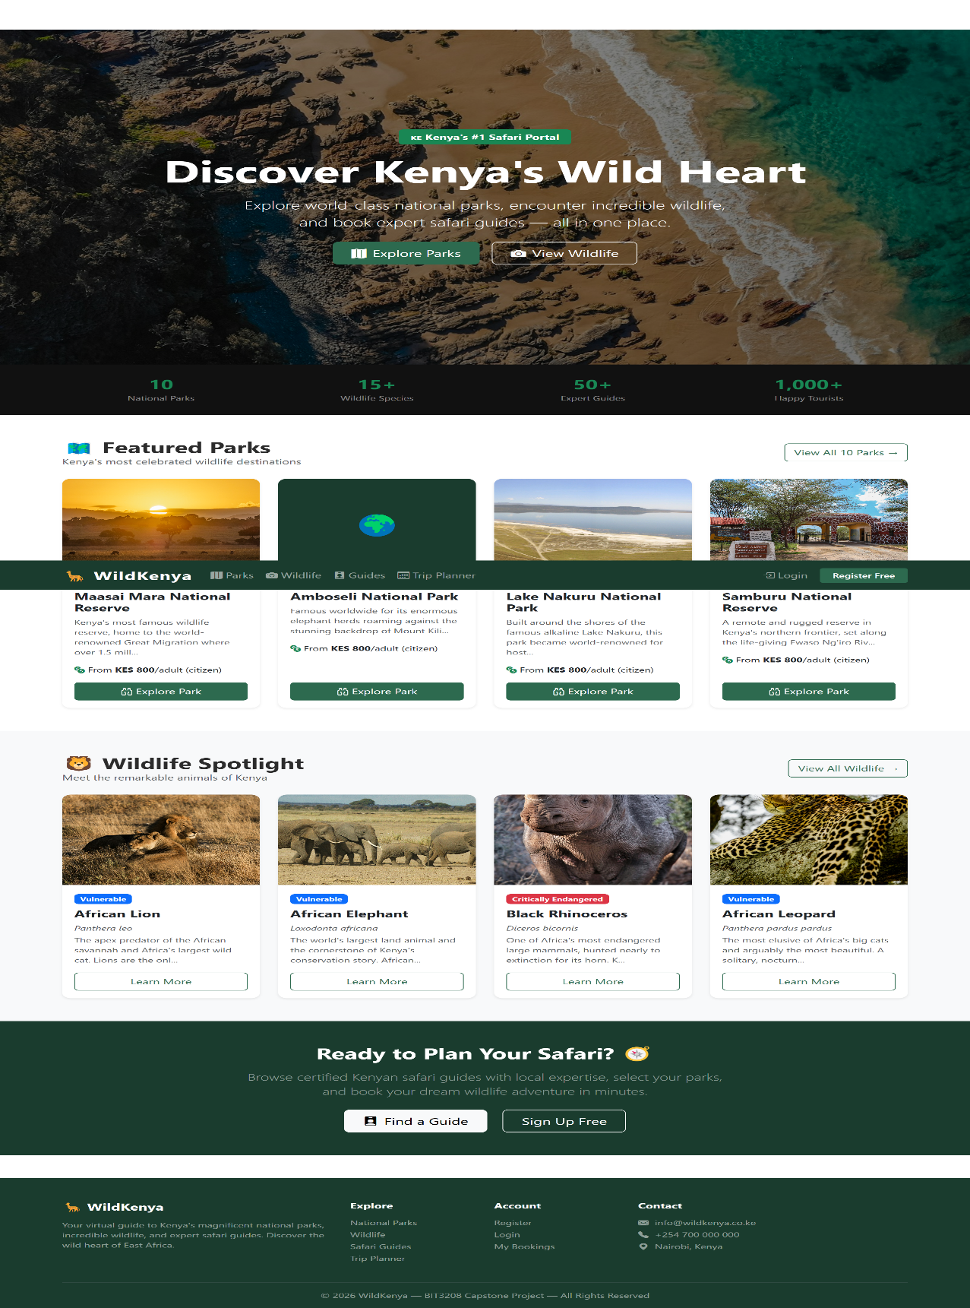

Fig 3-Screenshot of Homepage

Navigation bar and main menu
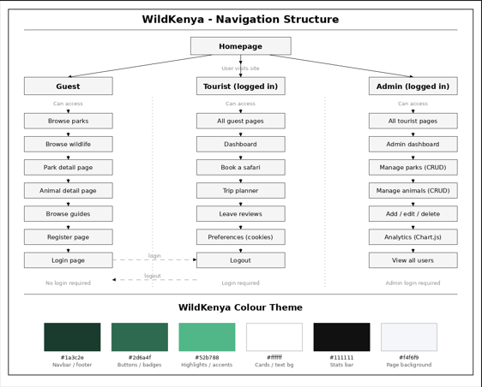

Fig 4-WildKenya navigation bar and main menu structure, navigation structure together with the color theme
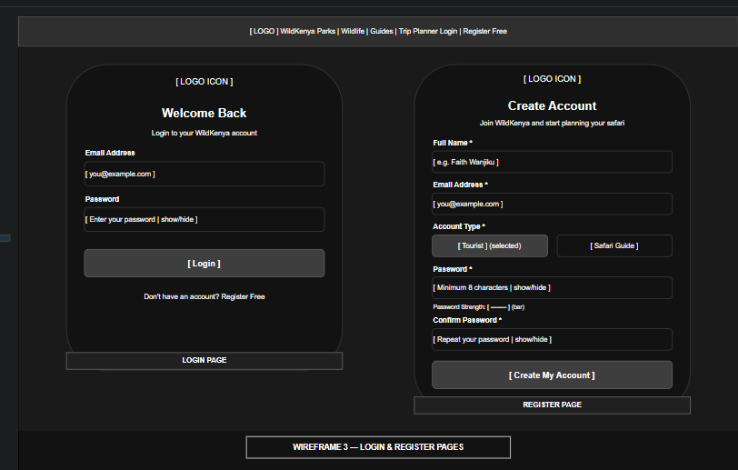

Fig 5: Login and register page wireframes showing form layouts side by side

WEEK 2 REFLECTION
Planning on the portal interface for WildKenya this week, while working on the back end functionality. Homepage, parks listing page, park detail page, login page, sign up page, user dashboard, and booking page were designed using the software Draw.io with 6 wireframes. It was decided that in the theme of Kenya's natural habitat and wildlife, a dark green colour theme (#1a3c2e) should be used. The responsive grid system of Bootstrap 5 made it a perfect choice to ensure that the website is mobile-friendly. The navigation bar was given in the top and the logo was placed at the left side of the website and the login links were placed at the right side of the website, following the website design norms. Three user roles were also to be created: Guest, Tourist and Admin with various levels of access and permissions.

WEEK 3 - JavaScript and PHP Basics
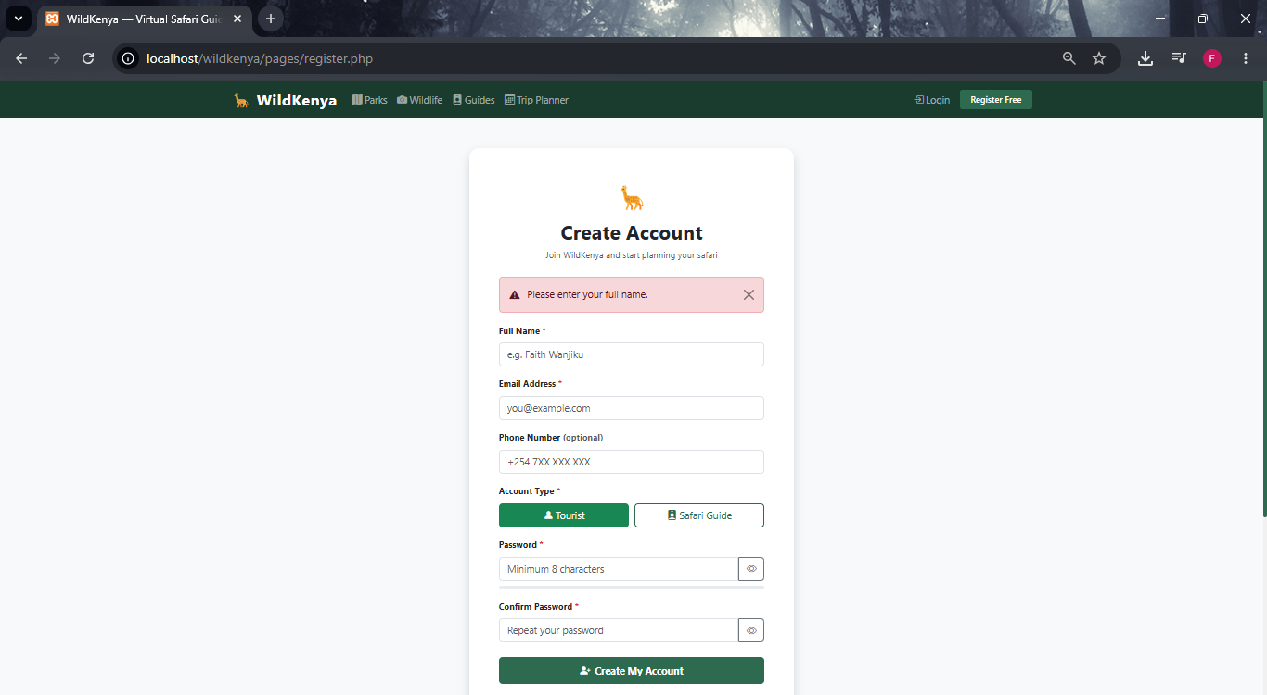

Fig 1-Register form showing a validation error
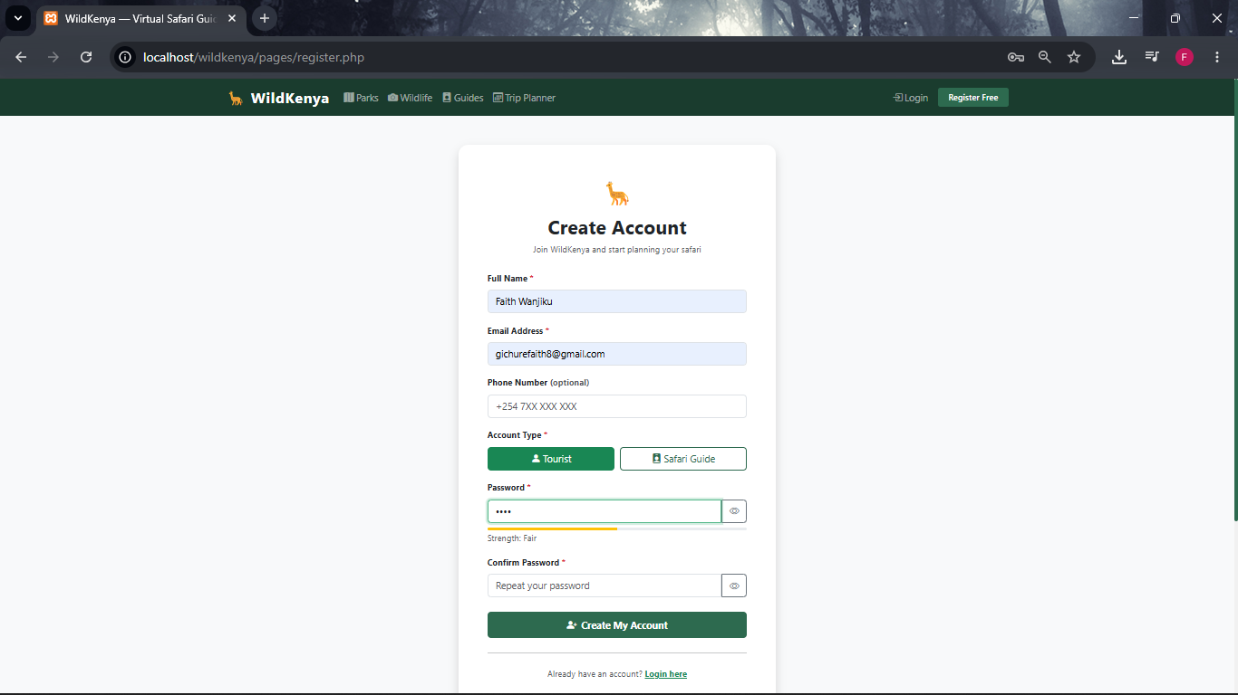

Fig 2-Register form showing the password strength bar changing

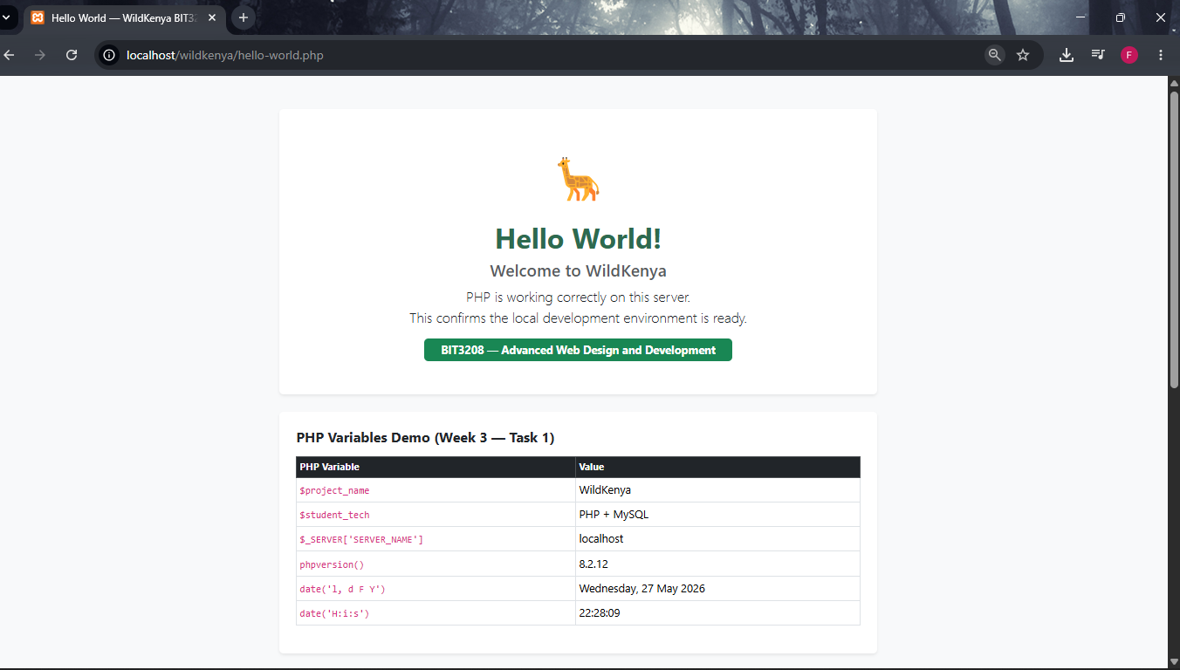
Fig 3- PHP variables demo showing echo output, PHP version and server information 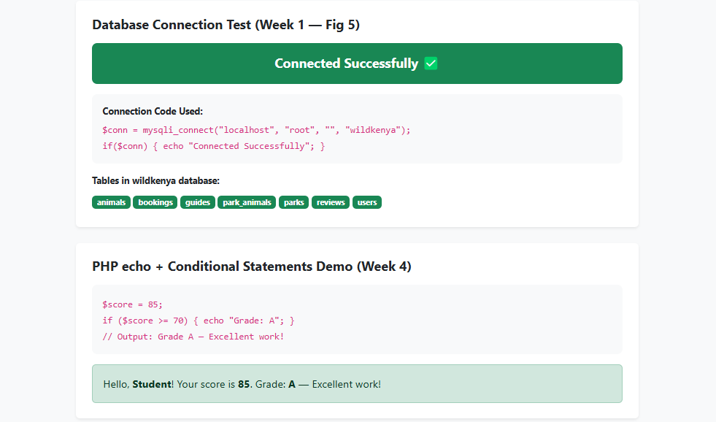

Fig 4-PHP mysqli_connect() database connection test returning Connected Successfully
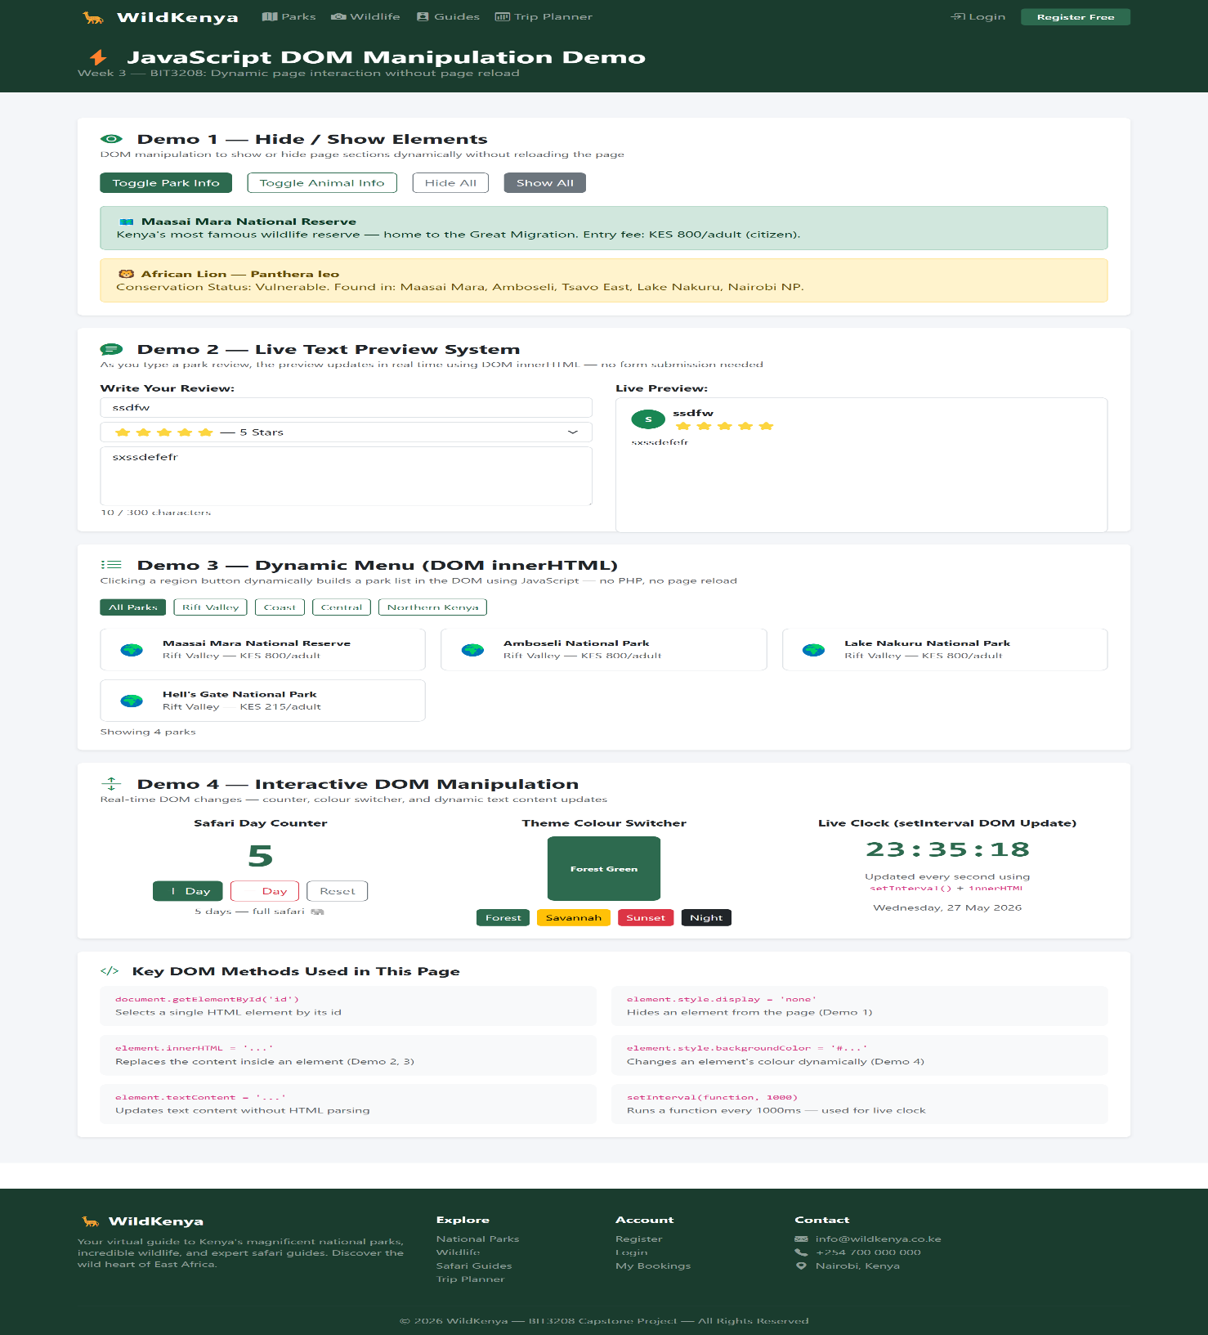

Fig 5: DOM manipulation live text preview updating review content in real time

WEEK 3 REFLECTION
This week I have added some JavaScript form validation and DOM manipulation to the Wild Kenya project, and started working with PHP for the backend. Empty form submission is prevented in Fig 1 by doing some JavaScript checks on the client side before submitting the form to the server. In the above fig 2, the strength of the password is checked by using regular expressions (regex) to examine the presence of upper-case characters, numbers and special characters. The PHP syntax code practice includes variables, echo statements and a successful mysqli_connect() database connection as seen in Fig 3 and Fig 4. When using inner HTML, as in Fig 5, DOM manipulation is used to show a live preview of the review, while the user is typing. These tasks helped to verify integration of the frontend and backend.

WEEK 4 - Server-Side PHP and Authentication
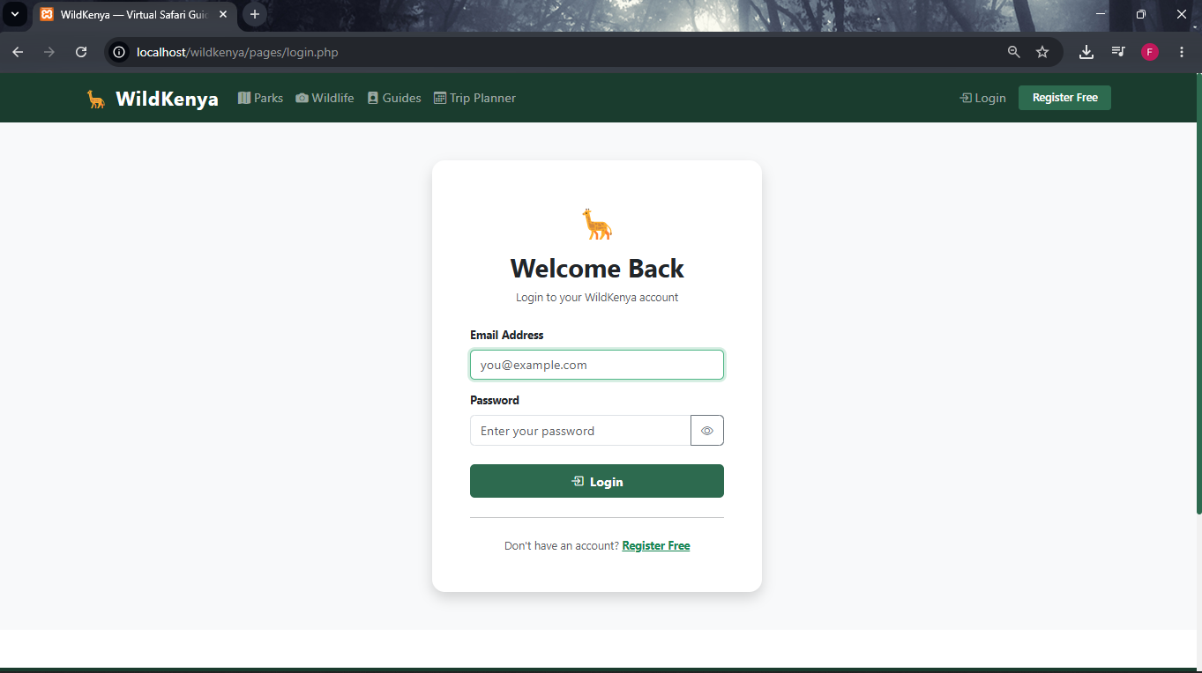

Fig 1-Login page
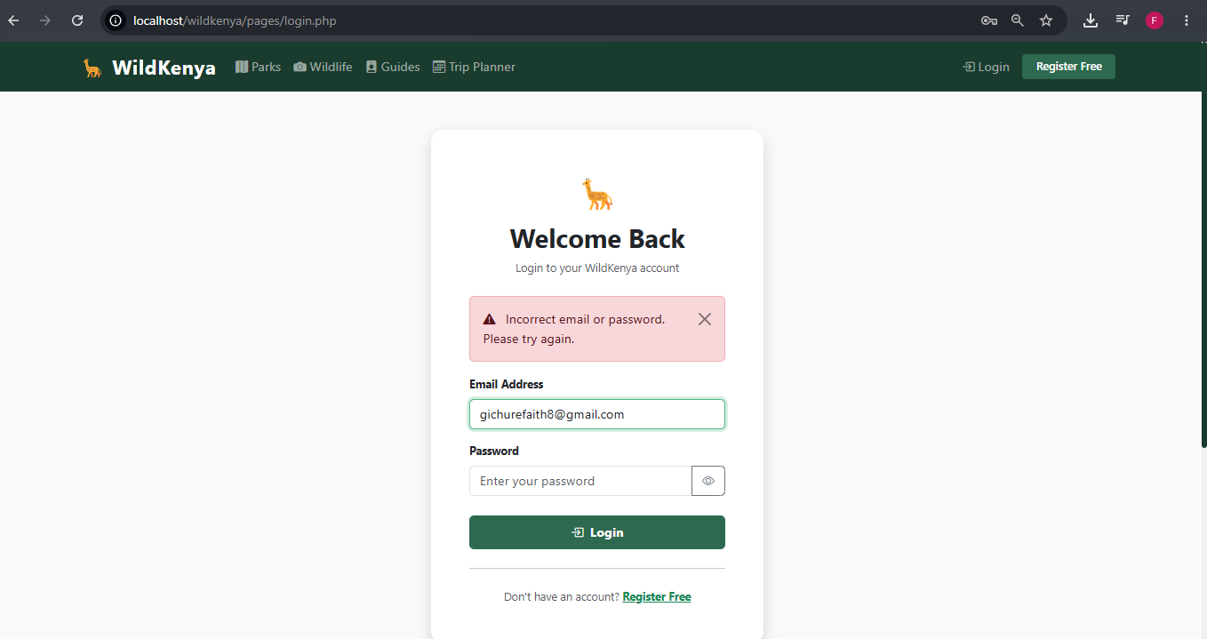

Fig 2- Incorrect password error

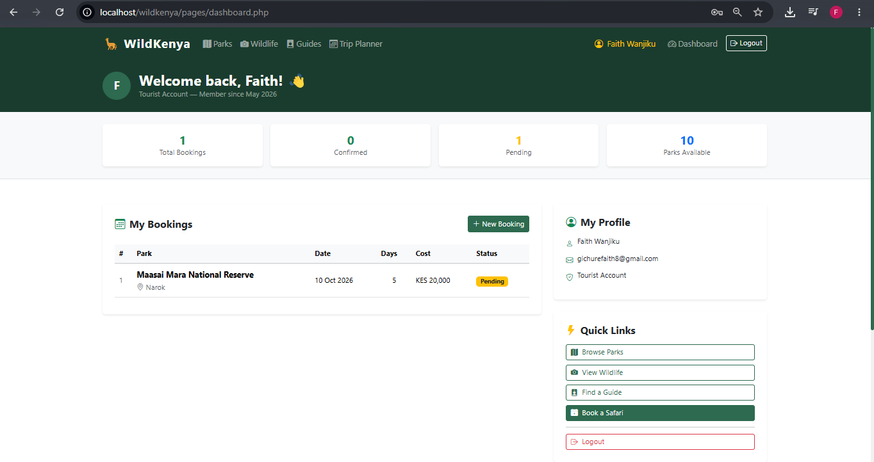

Fig 3-Dashboard after successful login
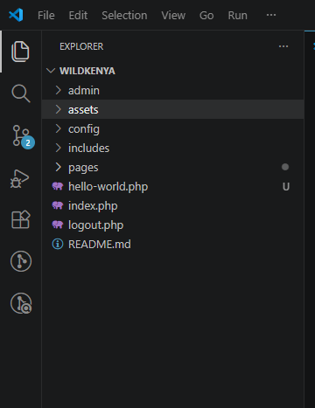

Fig 4-project folder structure

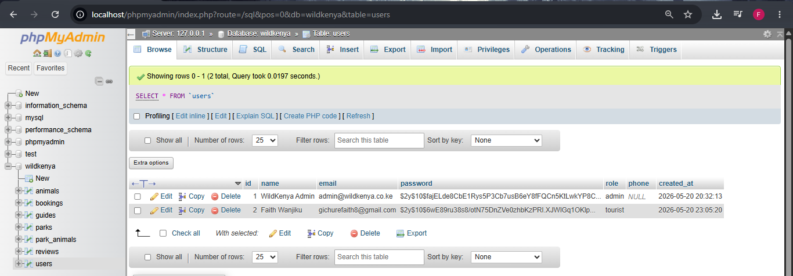

Fig 5-phpMyAdmin users table showing hashed password

WEEK 4 REFLECTION
This week I have changed the setup of the form to be server side and completed an authentication system using PHP. Fig 1 and Fig 2 are the logon screen created using POST method of form handling. The submitted email and password are processed using PHP, with the use of prepared statements to improve security, as well as to protect against SQL injection attacks. As you can see from Fig 3, PHP sessions are working fine — once a user logs in you can see that various information is stored in the $_SESSION array e.g. user ID, User Name, Email, and User Role, and then the User Dashboard will load specific user information. The project has a professional folder structure with four directories: config, includes, pages, admin and assets, organized for better maintainability and organization. Important evidence of security implementation is found in Fig 5 where we need to use password_hash(PASSWORD_BCRYPT) to hash the password, and then use password_verify() with a secure manner.

WEEK 5 - Database CRUD Operation
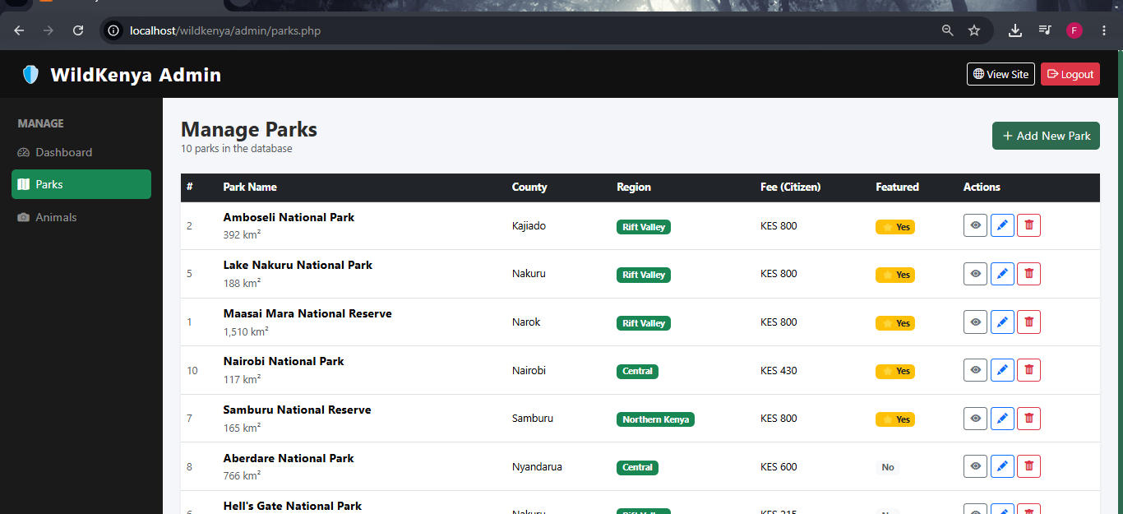

Fig 1-Admin parks table
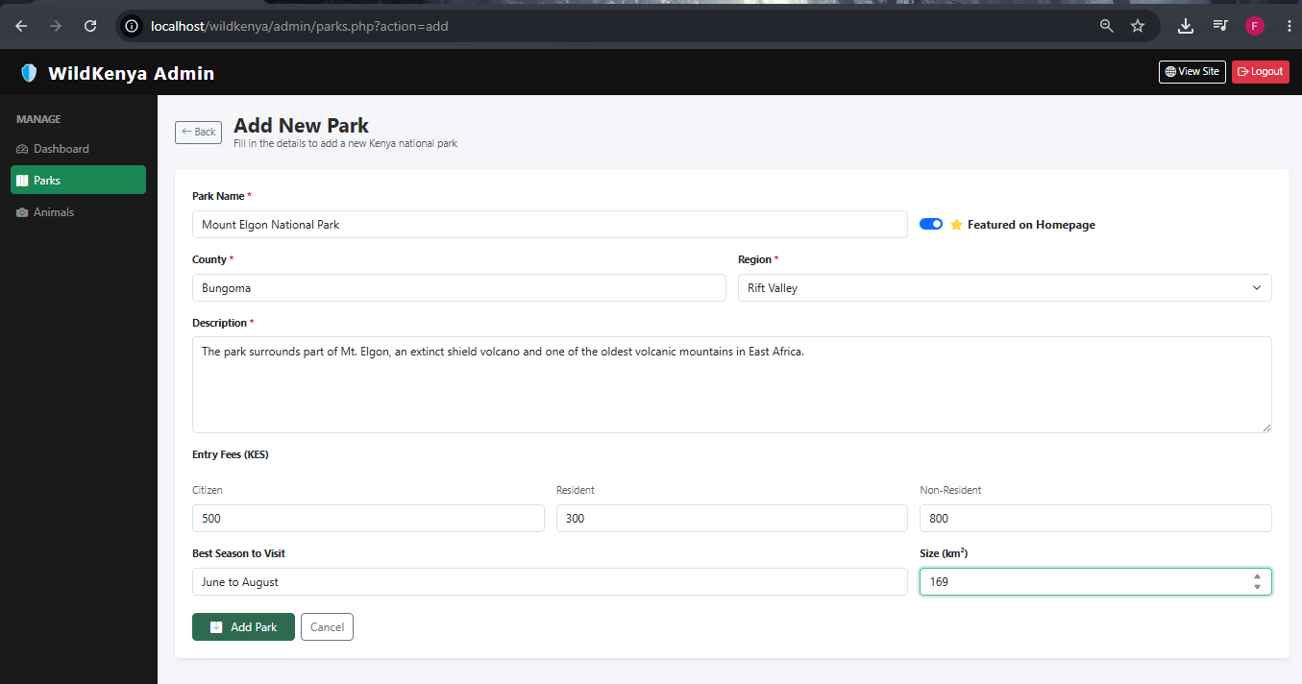

Fig 2-Add New Park form filled in

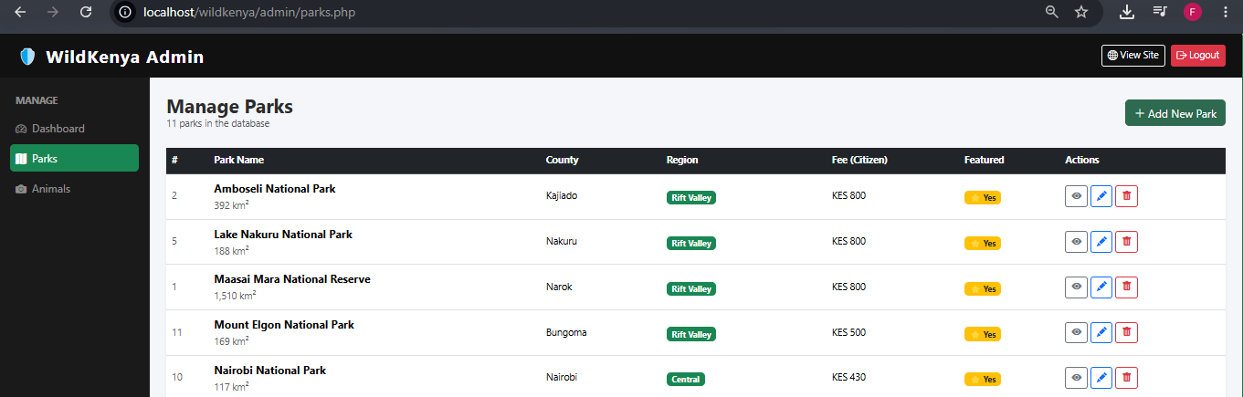

Fig 3-New Park appearing in the parks list after saving
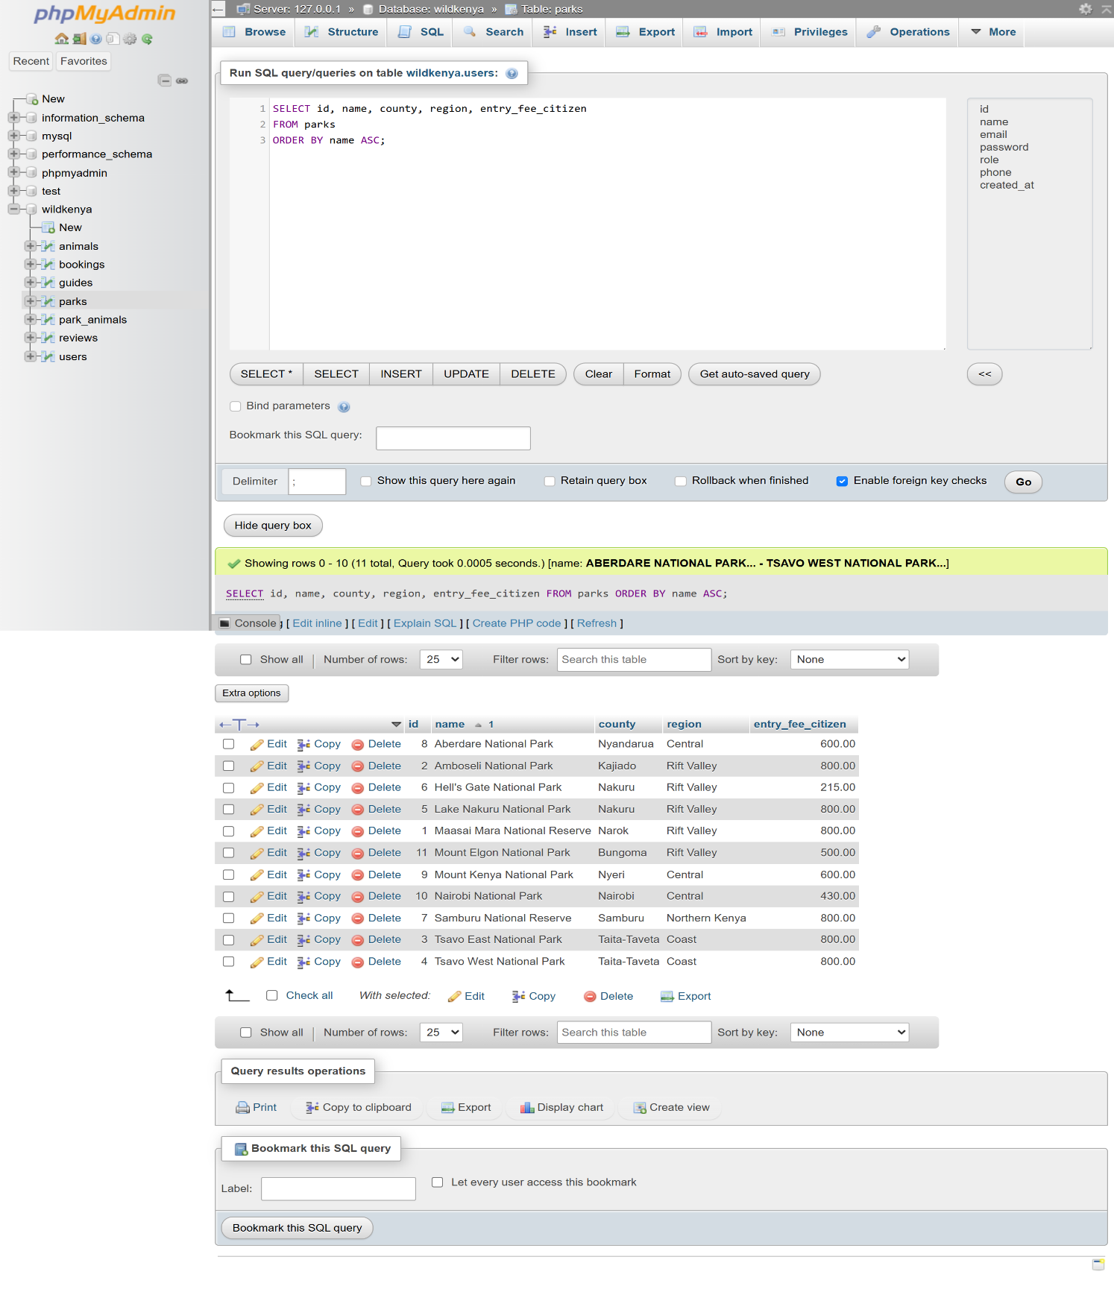

Fig 4-phpMyAdmin showing a SELECT query result

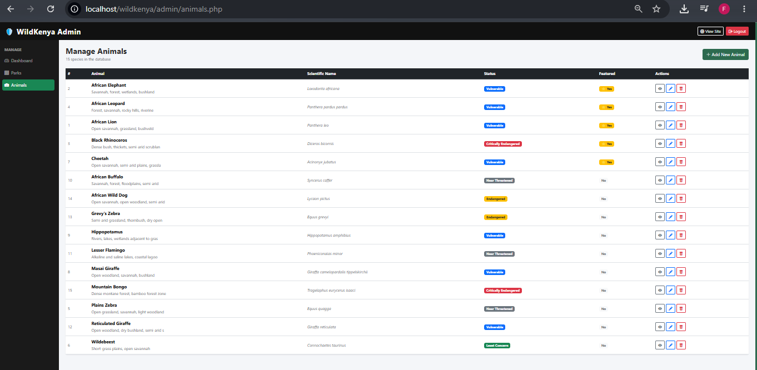

Fig 5-Admin Animals page showing all 15 species

WEEK 5 REFLECTION
In this week I created all CRUD database operations for the parks and animals using the admin panel. As can be seen in the above image (Fig 1), the parks manager is dynamically listing out all 10 Kenya national parks using SELE4CET queries on the MySQL database. In Fig 2, the “Add New Park” form is using a PHP prepared statement to insert into parks. The SELECT query in Fig 3 validates the data is being stored properly in the database in a raw SQL query. Figure 4 illustrates the UPDATE operation with an edit form to edit existing records with an UPDATE park SET. All CRUD operations in the database are executed with prepared statements which are protected from SQL injection attacks with bind_param(). The same CRUD system was successfully used for the 15 wildlife species as seen in Fig 5, which indicates that the database is working well in all modules.

WEEK 6 - CAT 1 Complete Application


Fig 1-Full Wild Kenya homepage

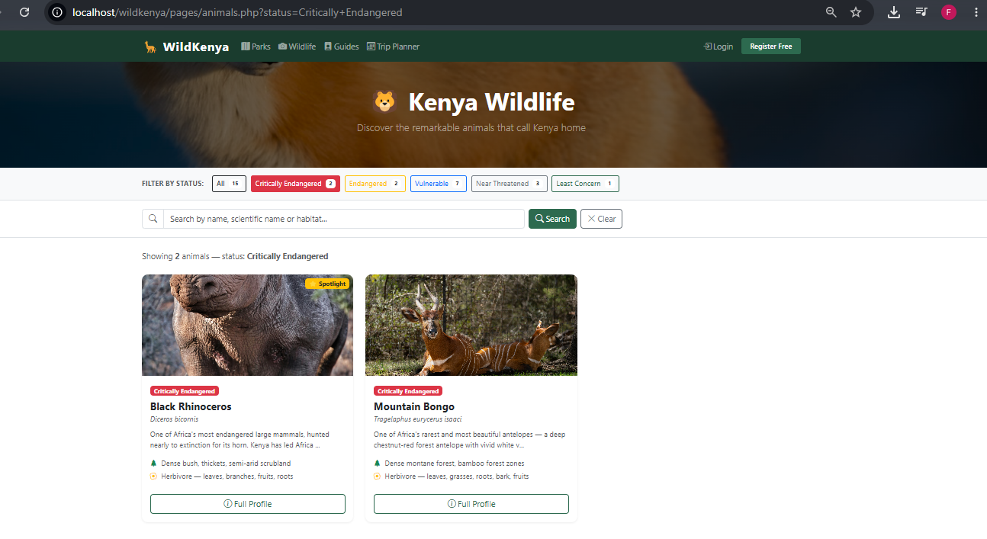

Fig 2-Wildlife page with conservation filter active

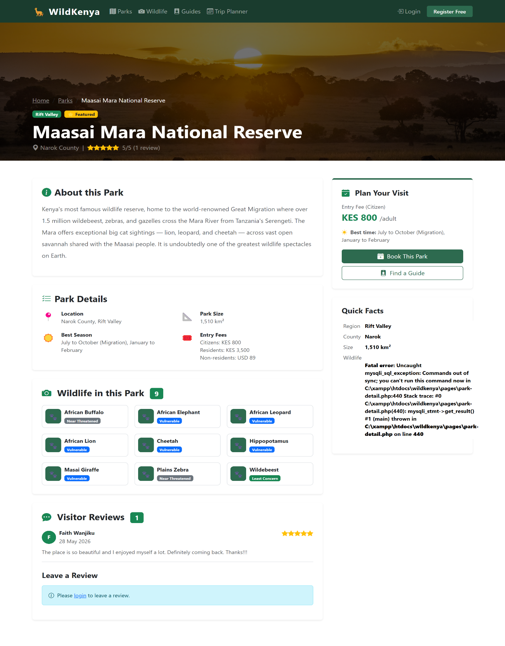

Fig 3-Park detail page showing wildlife list and reviews
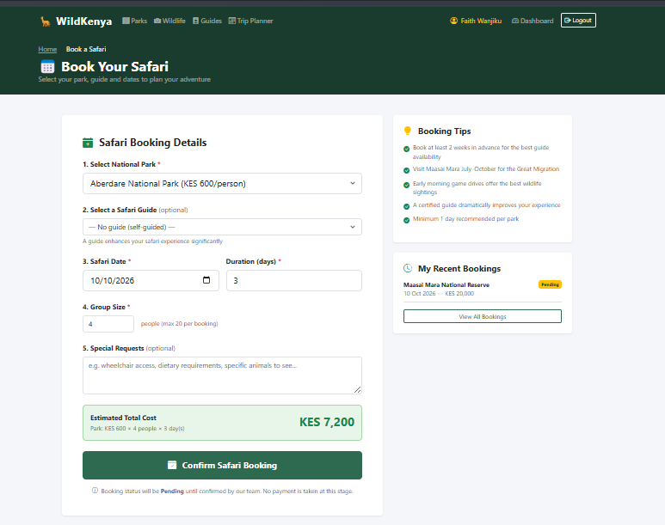

Fig 4-Booking page with live cost calculator showing a total
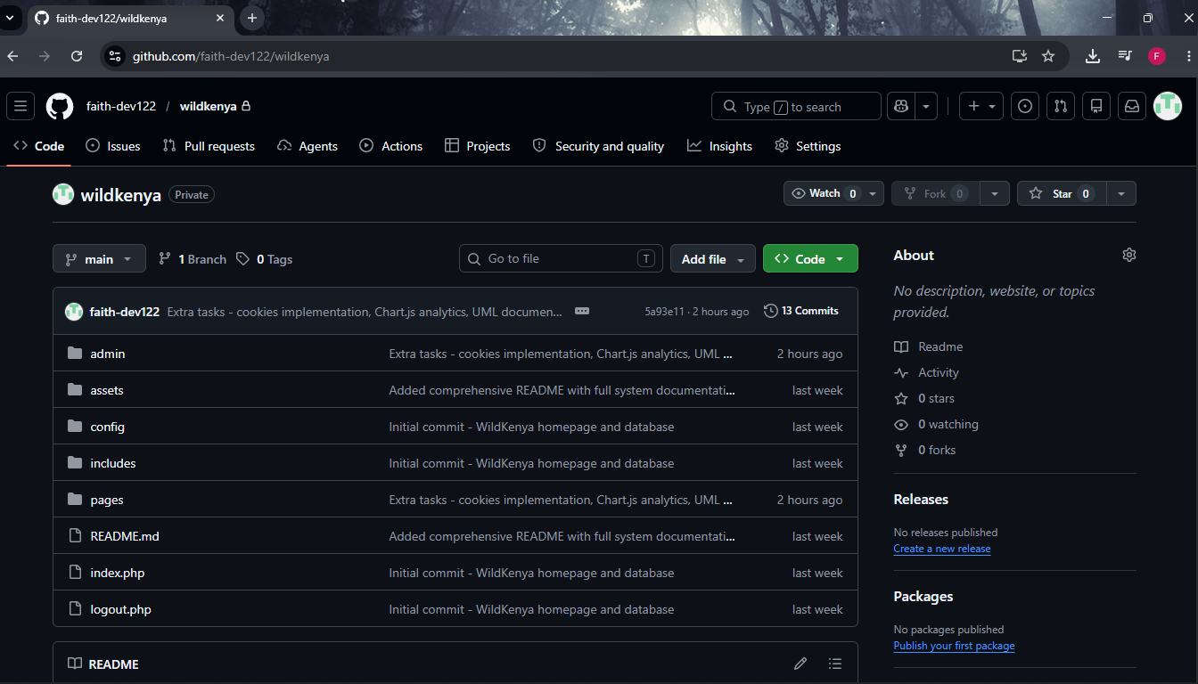

Fig 5-GitHub repository at github

WEEK 6 REFLECTION
The example in Fig 1 illustrates the dynamic generation of HTML, in which the PHP loop dynamically generates the park cards that are generated based on the results of the MySQL query. In Fig 2, JavaScript is used and acts as a complement to PHP; the filter buttons change the query string of the URL and PHP sends the appropriate filtered results from the database. In the park detail page, multiple tables have been joined together in the SQL query, as illustrated in Fig 3, to present related information such as user reviews and wildlife found in the park. The example in Fig 4 shows a live cost calculator created using JavaScript, that calculates the park fee for various sizes of groups and duration of time spent at the park in real time. The steady and gradual commits to GitHub over the 6 week period is shown in Fig 5, and evidence of progressive growth and development is seen.

